Bijlage **Voorbeelden huidige situatie**

**Overzichtkaart**

Overzichtskaart van panden in de BGT die nader zijn opgedeeld door gemeenten/bronhouders.

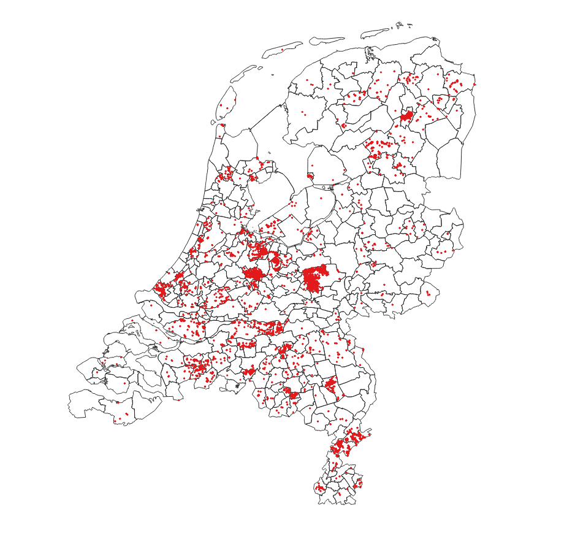

**Achterweg, Westland**

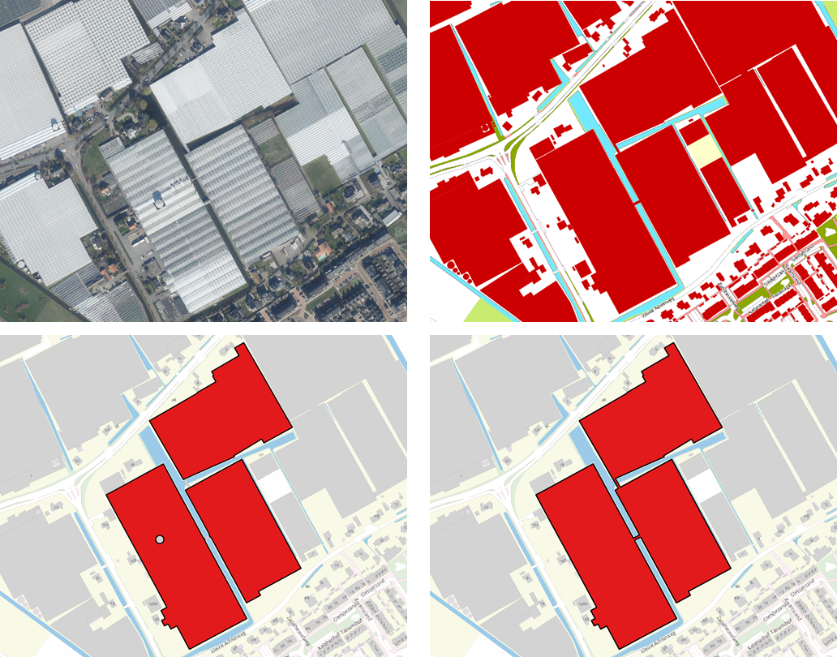

|  |  |  |  |  |
| --- | --- | --- | --- | --- |
| BGT-identificatie | tijdstipregistratie | BAG-identificatie | bronhouder | relatievehoogte |
| G1783.a7c60324ef6449d2a055fe6d0503bd62 | 3-5-2023 16:38 | 11783100000001188 | G1783 | 0 |
| G1783.6860512d15a94050b8be7f33a726174c | 3-5-2023 16:38 | 1783100000001188 | G1783 | 1 |

Borgstee, Assen

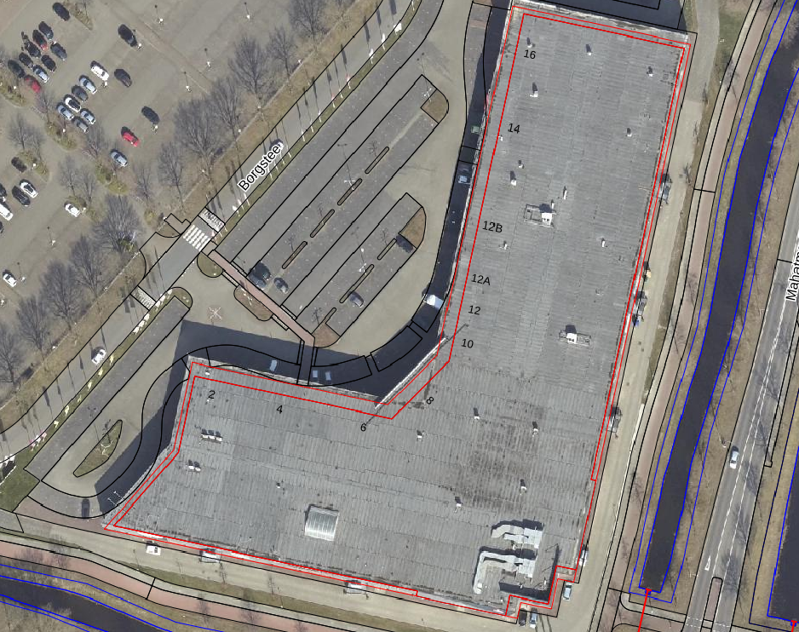 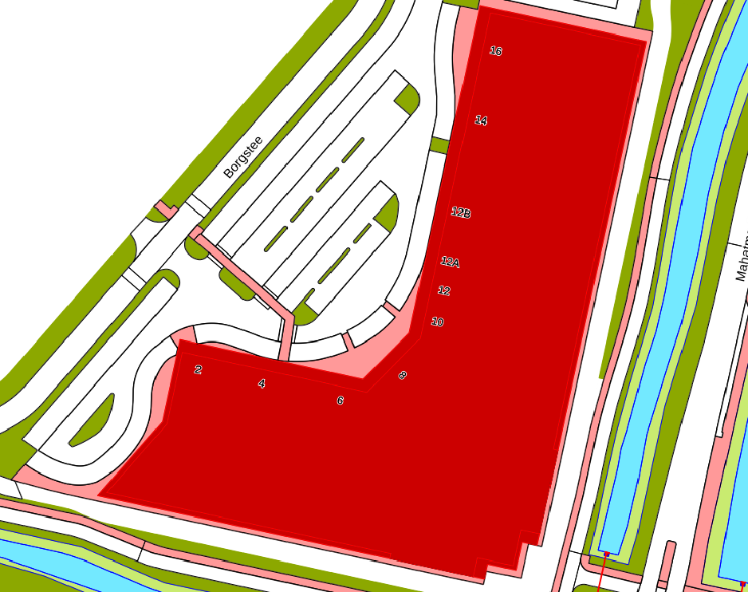

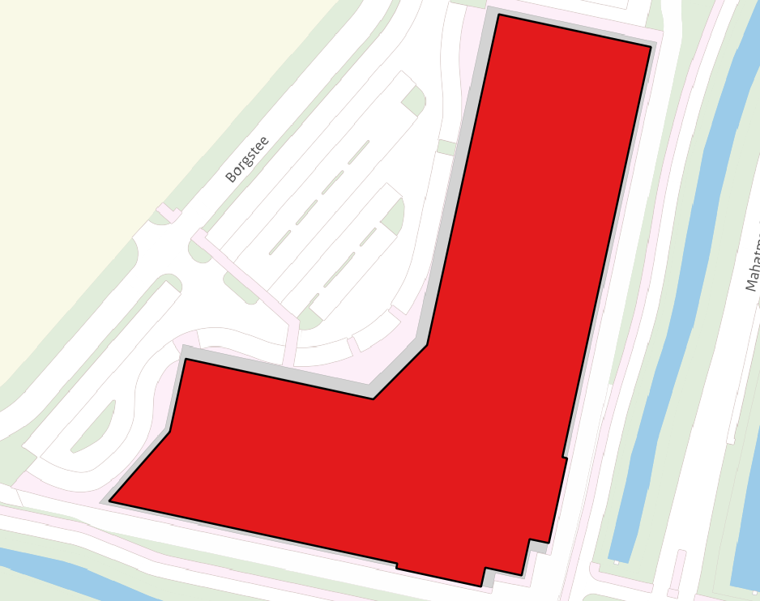 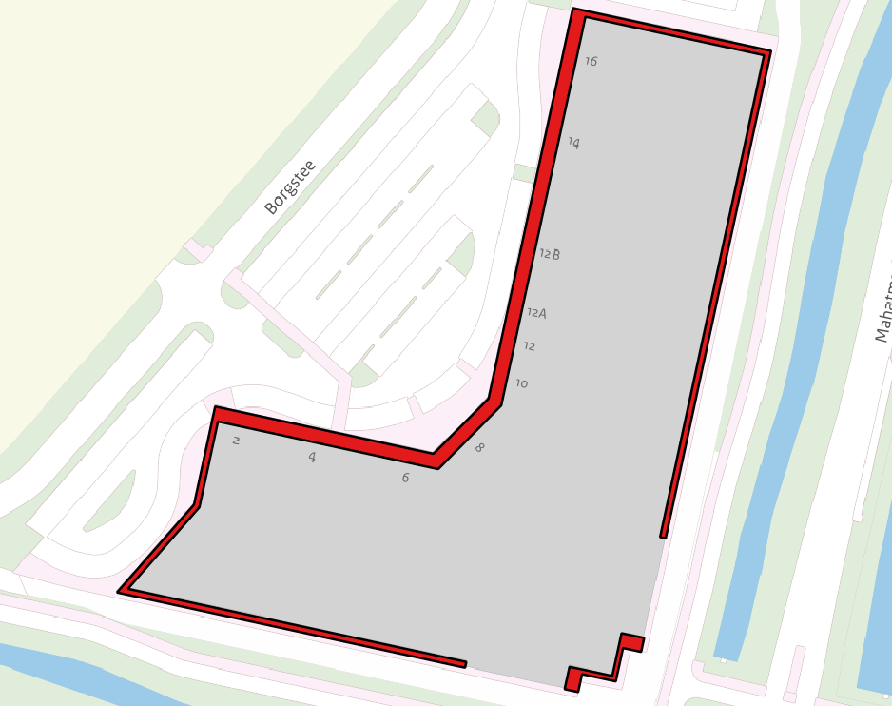

|  |  |  |  |  |
| --- | --- | --- | --- | --- |
| BGT-identificatie | tijdstipregistratie | BAG-identificatie | bronhouder | relatievehoogte |
| G0106.e0f677dc892149e5888614718f61112d | 15-1-2016 09:24:29 | 0106100000000018 | G0106 | 0 |
| G0106.d7f58d4311fa40eb8a41e2e98e698312 (links) | 4-1-2023 11:08:15 | 0106100000000018 | G0106 | 1 |
| G0106.9c01f9f7b639467ea1a80d54813598bb (rechtsonderin) | 4-1-2023 11:08:15 | 0106100000000018 | G0106 | 1 |

Homeruslaan, Assen

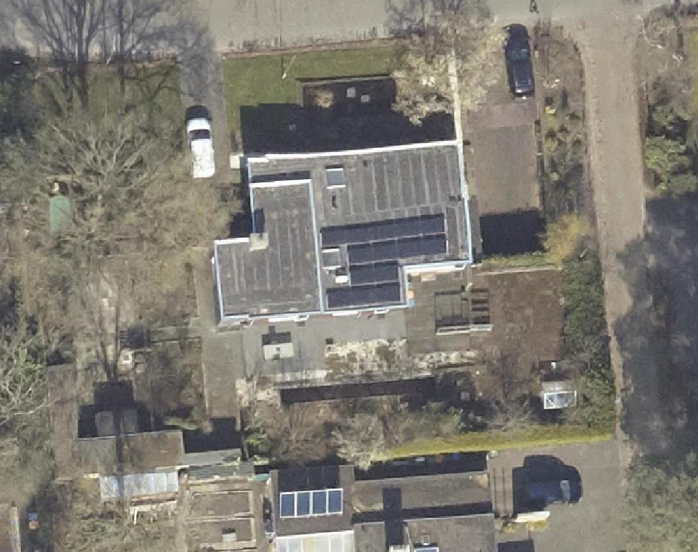 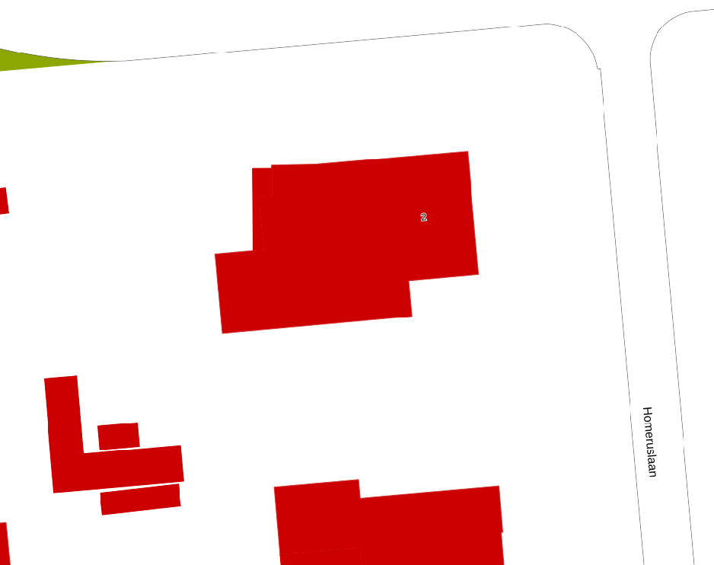

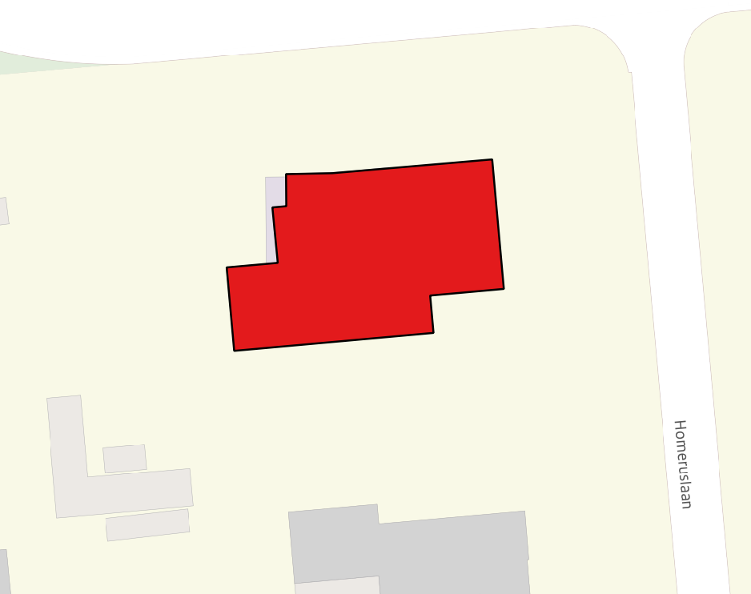 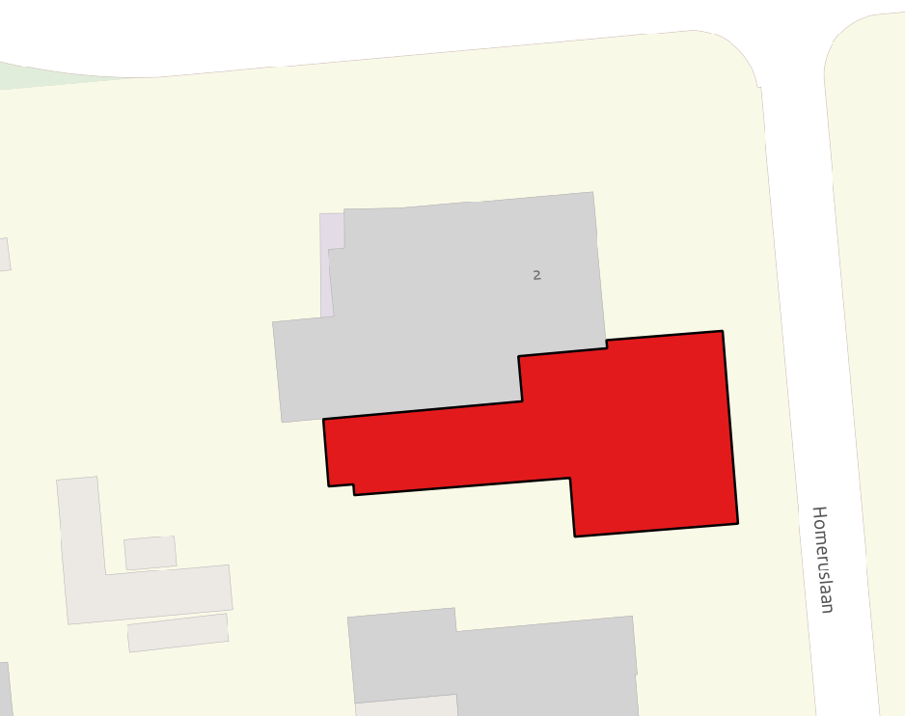

|  |  |  |  |  |
| --- | --- | --- | --- | --- |
| BGT-identificatie | tijdstipregistratie | BAG-identificatie | bronhouder | relatievehoogte |
| G0106.ebb26acc9de34150a9b881b35430cd40 | 26-1-2016 10:21:55 | 0106100000001279 | G0106 | 0 |
| G0106.c140a26d903942ea8d8a143e0b764128 | 27-1-2023 12:50:18 | 0106100000001279 | G0106 | 1 |

**Zuwestraat, Baarn**

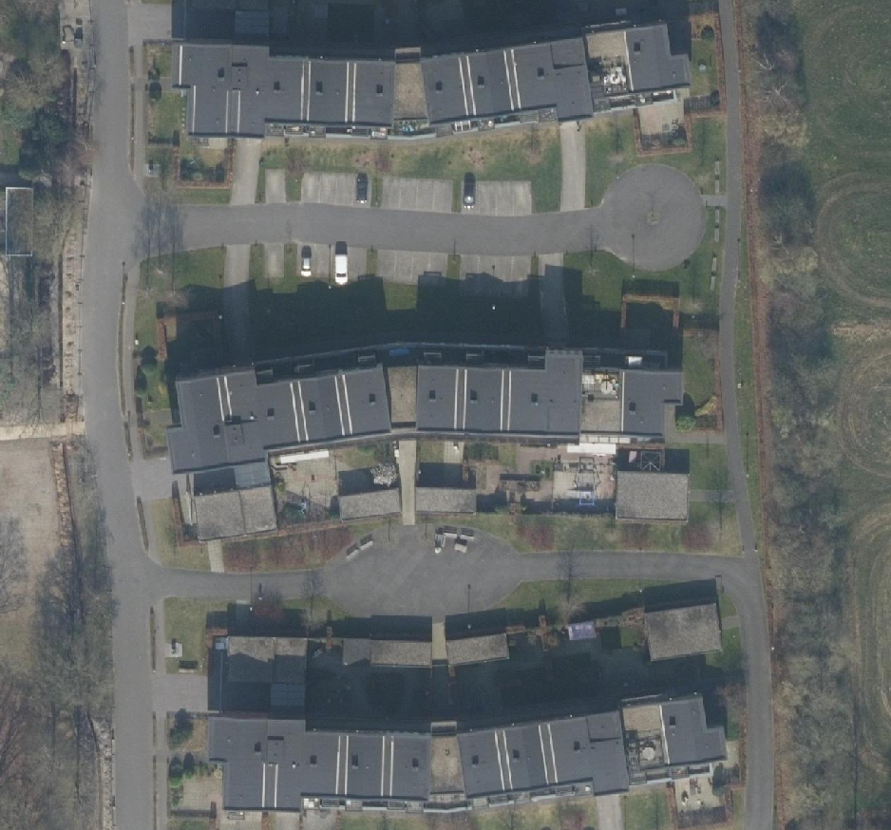 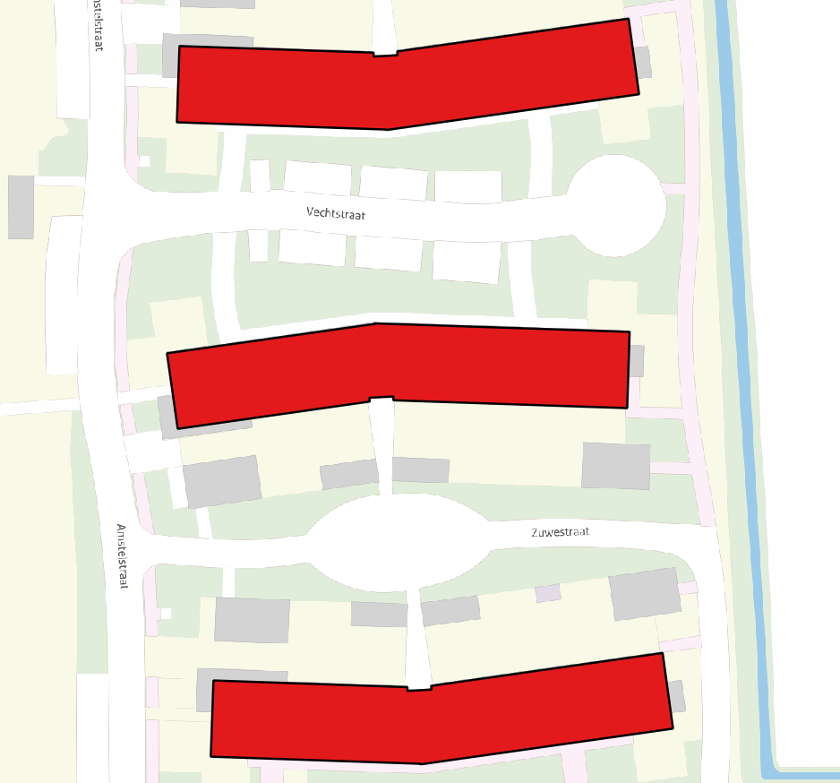 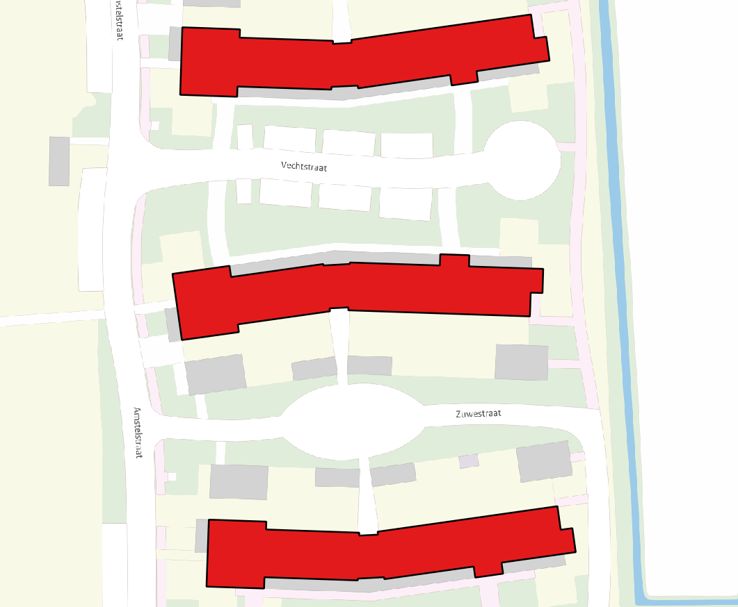 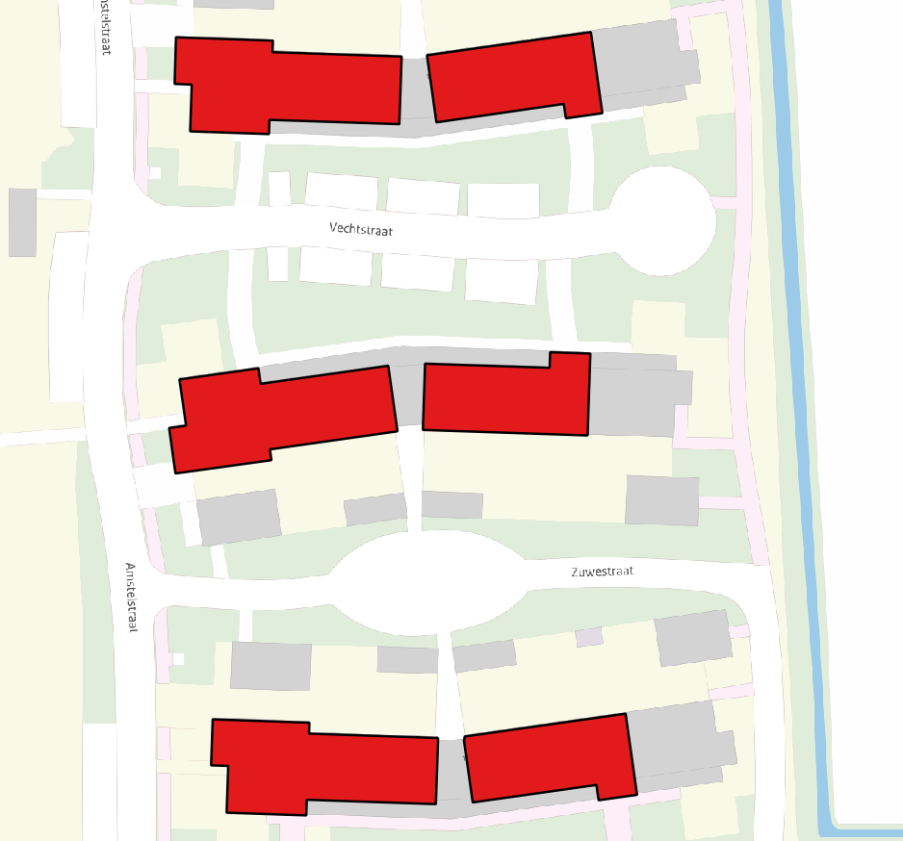

|  |  |  |  |  |
| --- | --- | --- | --- | --- |
| BGT-identificatie | tijdstipregistratie | BAG-identificatie | bronhouder | relatievehoogte |
| G0308.71dcf73021d94842acfad18b82bb06eb | 6-9-2018 15:31:54 | 0308100000016010 | G0308 | 0 |
| G0308.840054e04533472783e5a7cbe5cb5f79 | 5-5-2023 11:56:17 | 0308100000016010 | G0308 | 1 |
| G0308.9f9284db5f794be29c130dc5908da85b | 5-5-2023 11:56:17 | 0308100000016010 | G0308 | 2 |
| G0308.ab4b706fd30e4697b7efbd7ecf6e5b37 | 5-5-2023 11:56:17 | 0308100000016010 | G0308 | 2 |

Burg Grothestraat, Soest

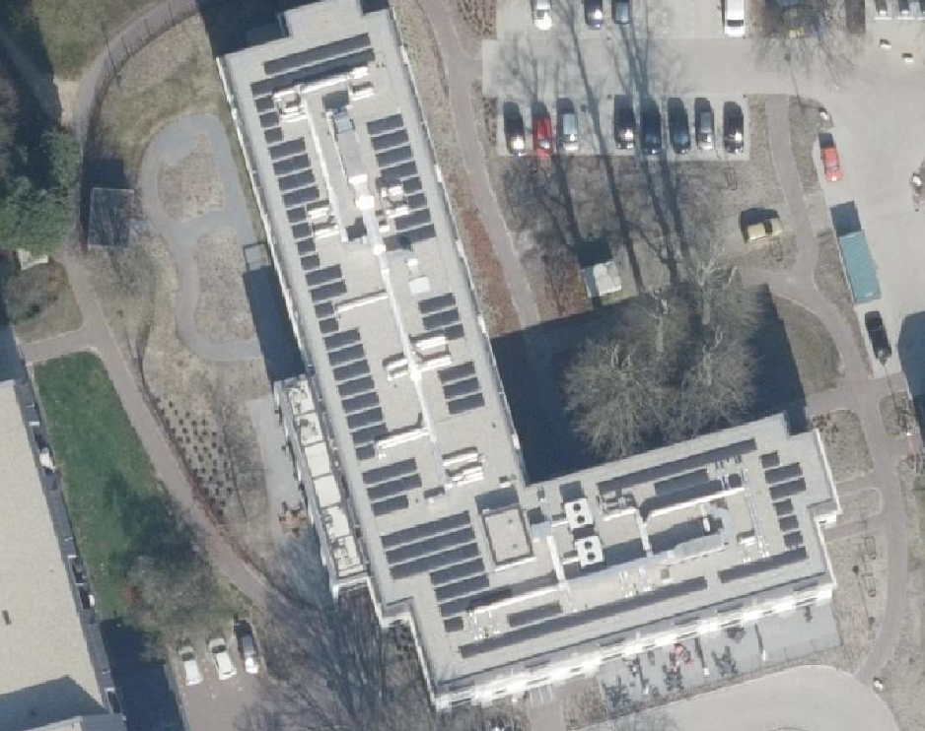 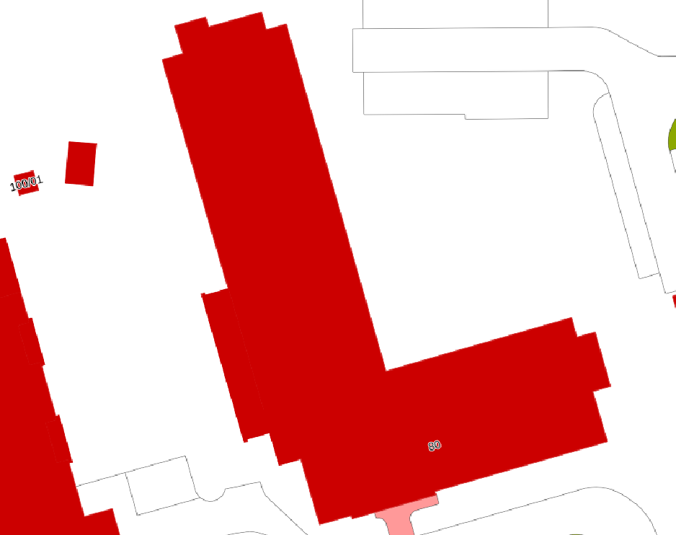

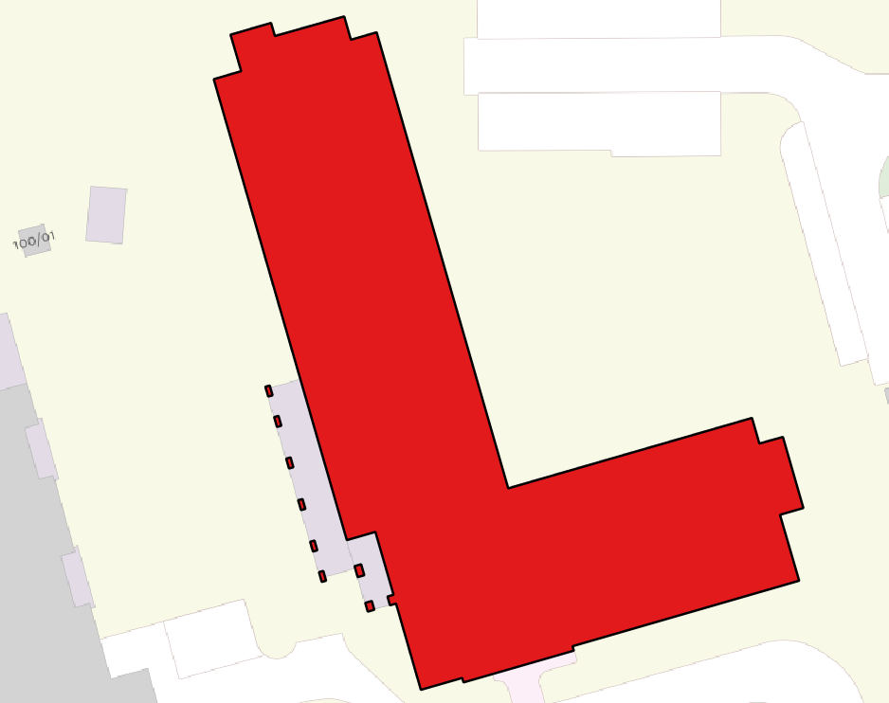 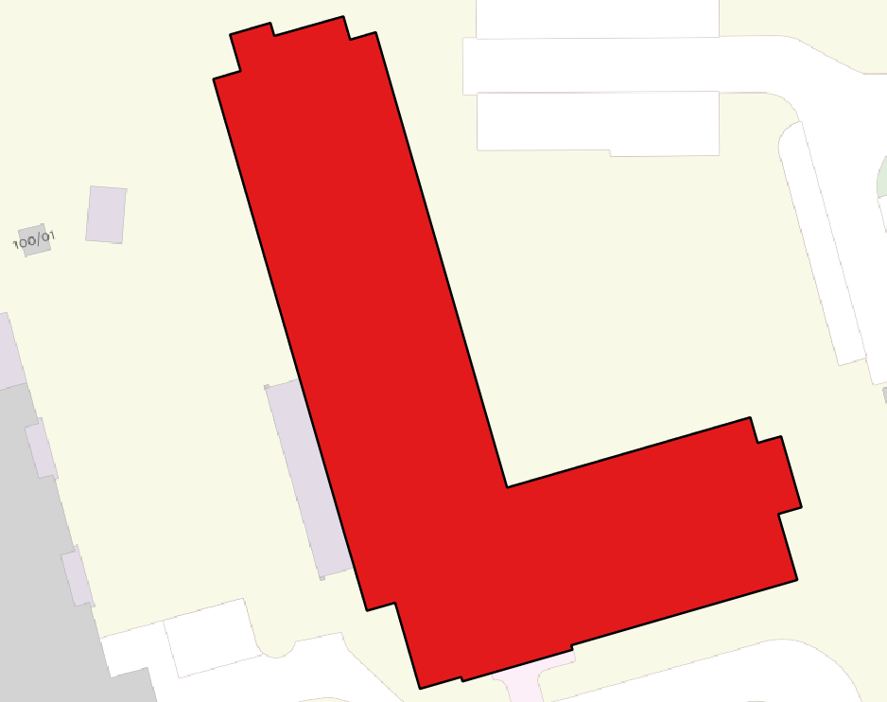

|  |  |  |  |  |
| --- | --- | --- | --- | --- |
| BGT-identificatie | tijdstipregistratie | BAG-identificatie | bronhouder | relatievehoogte |
| G0342.98b55e1c30c64251a2d5da1c7cd35b53 | 15-8-2022 07:24:37 | 0342100000027961 | G0106 | 0 |
| G0342.cad54f4caf63486fa0e219221c36e315 | 12-4-2023 13:29:50 | 0342100000027961 | G0342 | 1 |

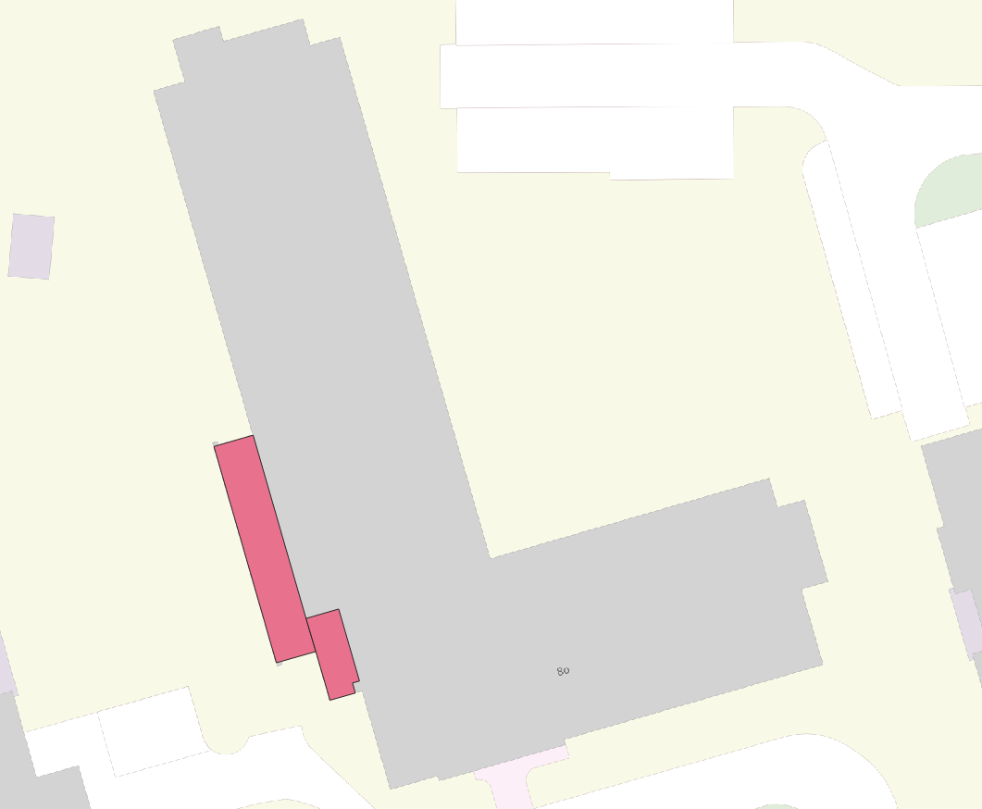 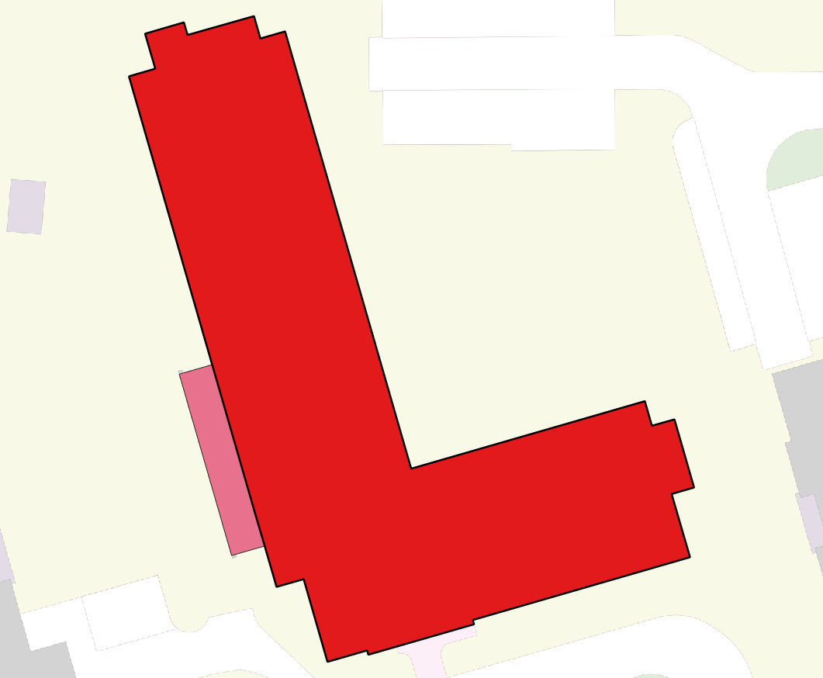

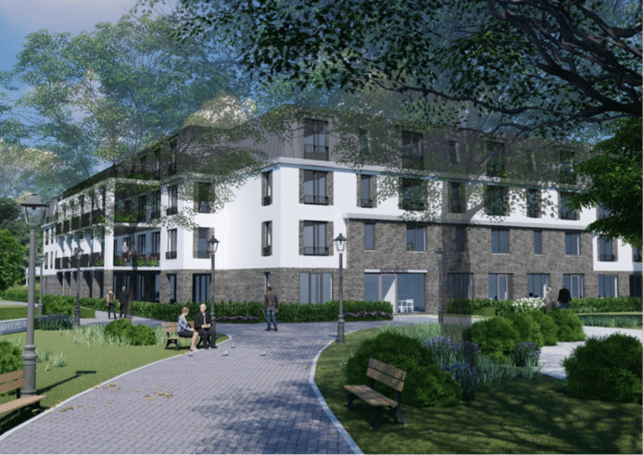

Gebouwinstallatie – luifel

|  |  |  |  |  |
| --- | --- | --- | --- | --- |
| G0342.7b37d6d219244ff1922b7272133f709d | 28-4-2021 12:21:57 | - | G0342 | 1 |
| G0342.ba24aa3e3ef1469ba80cac9f0401290d | 28-4-2021 12:21:57 | - | G0342 | 1 |

**Gubbelstraat, Maastricht**  
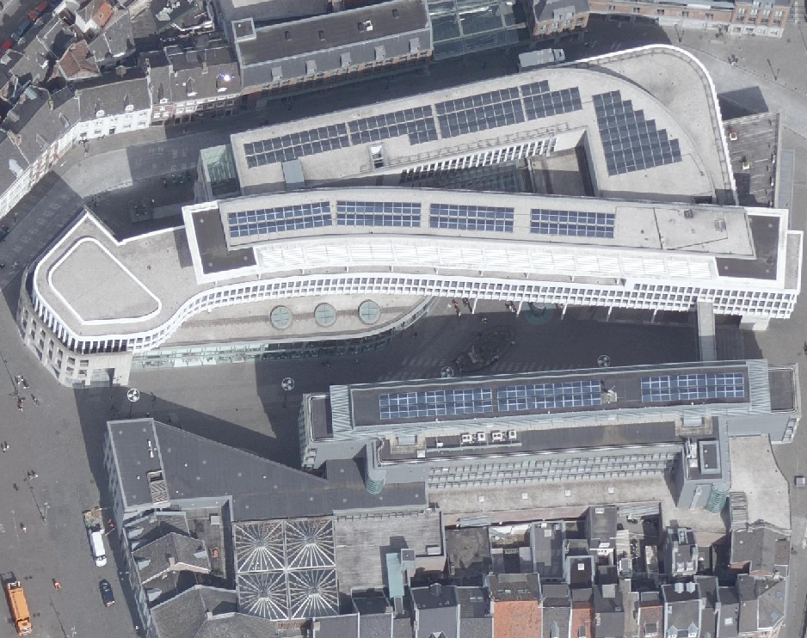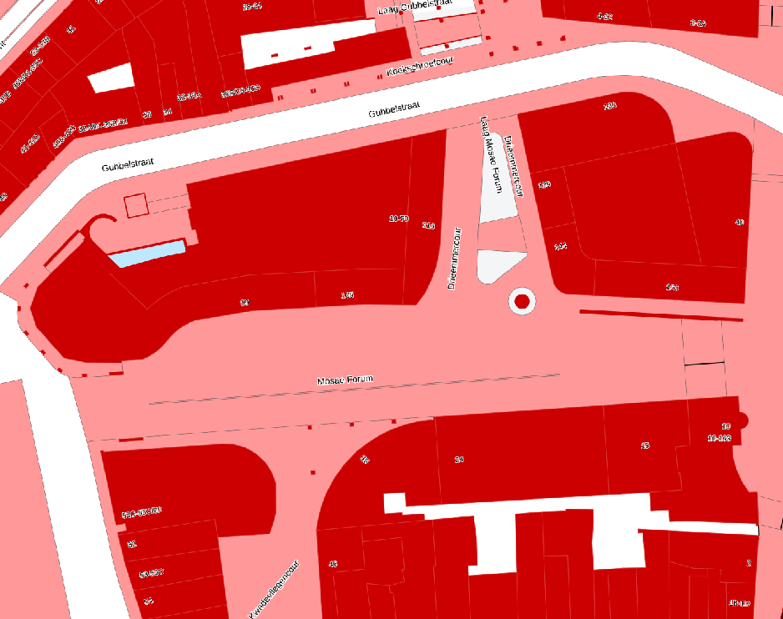 -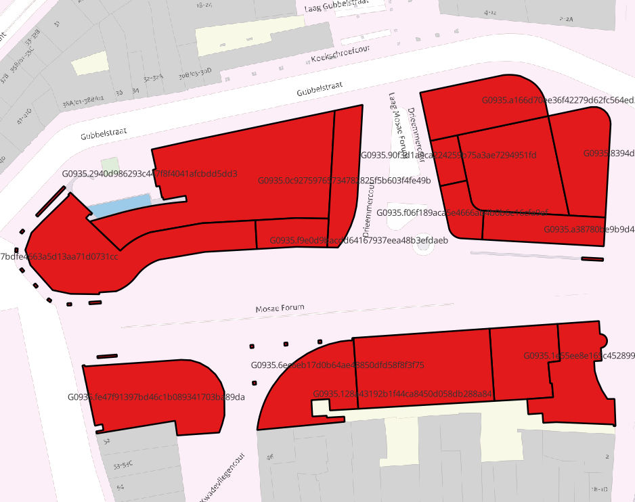 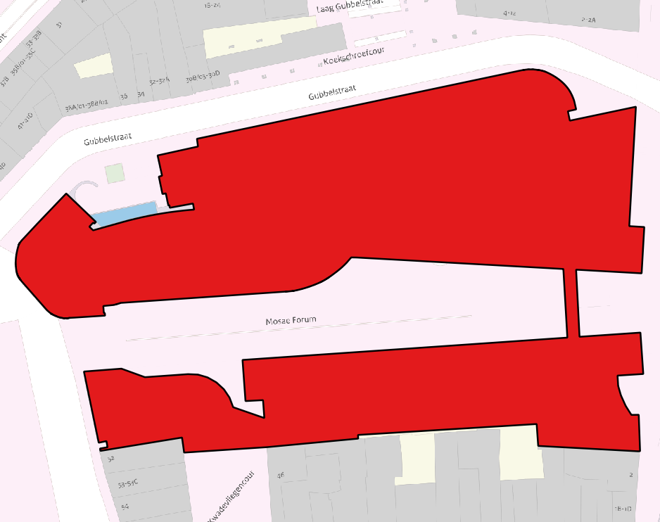

|  |  |  |  |  |
| --- | --- | --- | --- | --- |
| BGT-identificatie | tijdstipregistratie | BAG-identificatie | bronhouder | relatievehoogte |
|  |  |  |  |  |

G0935.2940d986293c447f8f4041afcbdd5dd3, 14-12-2017 11:41:22 (West-Europa (standaardtijd))

G0935.e5700b97bdfe4663a5d13aa71d0731cc, 4-10-2018 12:10:53

G0935.f9e0d9bacdd64167937eea48b3efdaeb, 4-10-2018 12:10:54

G0935.0c92759765734782825f5b603f4fe49b, 4-10-2018 12:10:53

G0935.90f3d1a9ca224259b75a3ae7294951fd, 4-10-2018 12:10:53

G0935.f06f189aca5e4666ab4b0b6e16cfa9ef, 4-10-2018 12:10:59

G0935.a38780be9b9d4149b6ec5d876fe5bc09, 4-10-2018 12:10:57

G0935.8394d55a05a54137aaa83046e54fff32, 4-10-2018 12:10:57

G0935.a166d70ee36f42279d62fc564ed2ccc8, 4-10-2018 12:10:54 (West-Europa (zomertijd))

G0935.fe47f91397bd46c1b089341703ba89da, 30-9-2022 11:03:58 (West-Europa (zomertijd))

G0935.128a43192b1f44ca8450d058db288a84, 14-12-2017 11:42:32 (West-Europa (standaardtijd))

G0935.6ec6eb17d0b64ae48850dfd58f8f3f75, 14-12-2017 11:40:15 (West-Europa (standaardtijd))

G0935.1e55ee8e165c4528992e095bba1e792b, 14-12-2017 11:40:38 (West-Europa (standaardtijd))

G0935

0935100000021156

Westerplein, Berkel en Rodenrijs

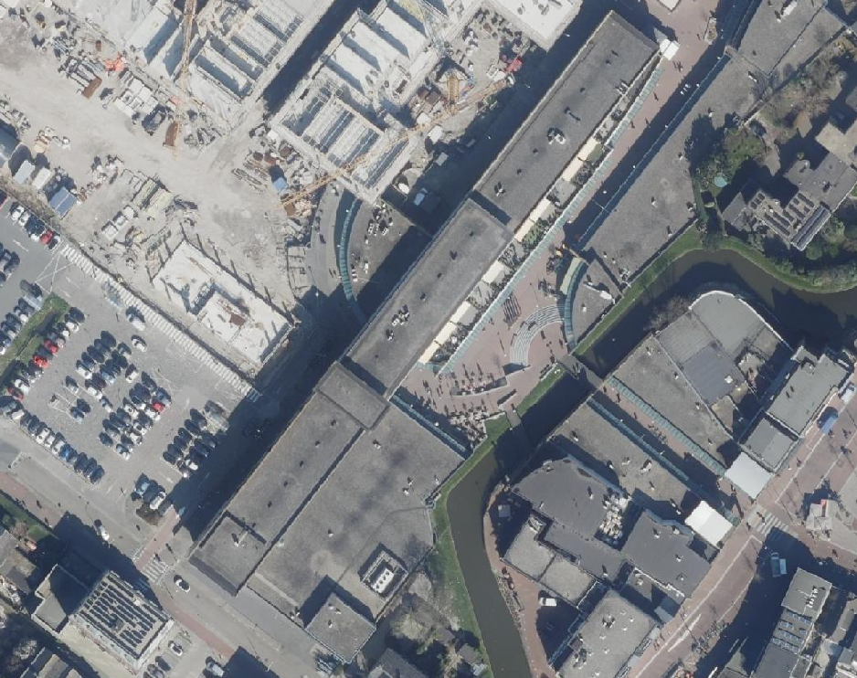 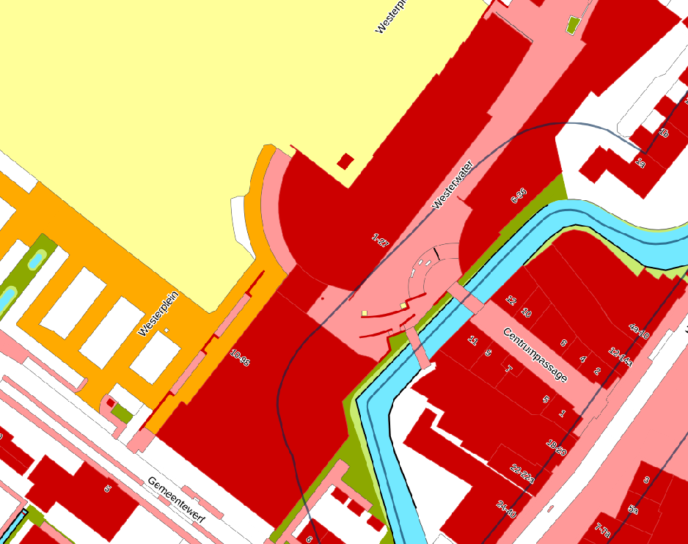

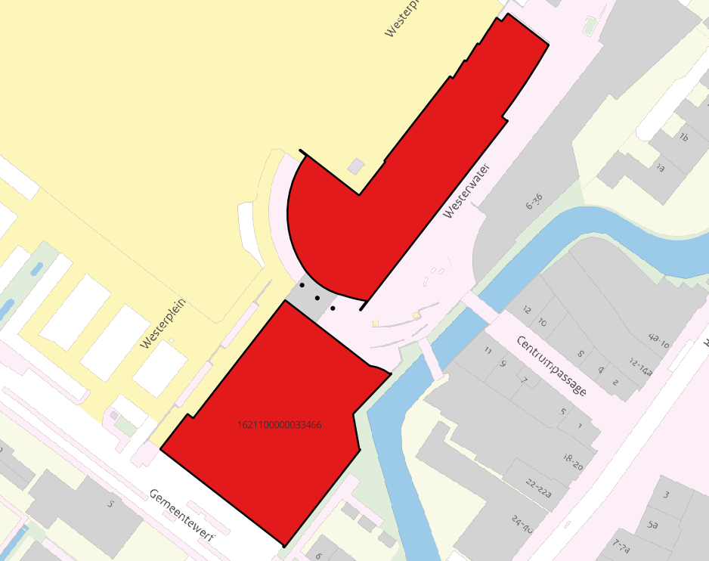 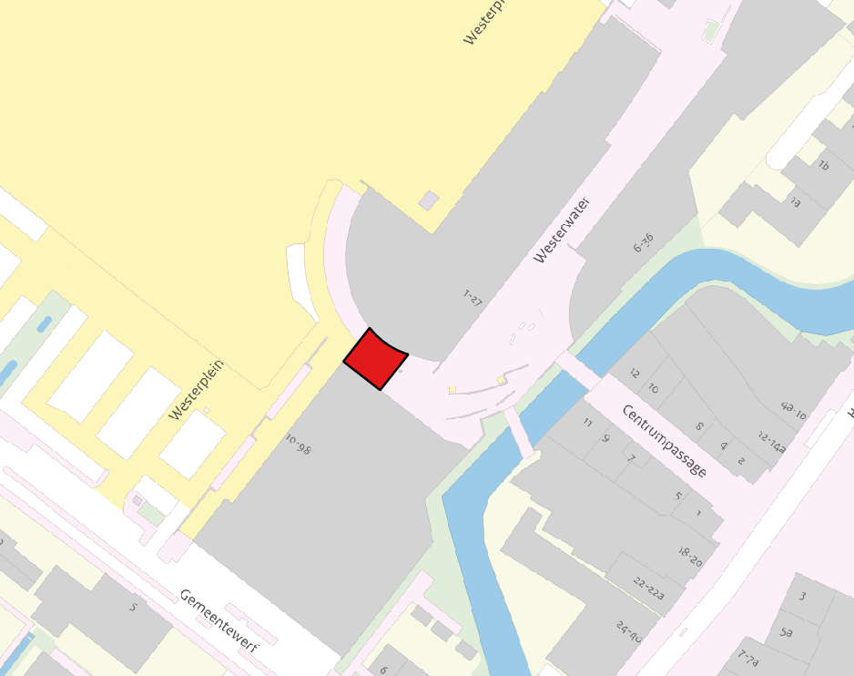

|  |  |  |  |  |
| --- | --- | --- | --- | --- |
| BGT-identificatie | tijdstipregistratie | BAG-identificatie | bronhouder | relatievehoogte |
| G1621.b074b6999d3a438192a1387ea538c016 | 21-2-2022 16:24:07 | 1621100000033466 | G1621 | 0 |
| G1621.29dcd82c215b4c41a8f2326b325f560b | 21-2-2022 16:24:07 | 1621100000033466 | G1621 | 1 |

**Arent van Lierstraat, Puttershoek**

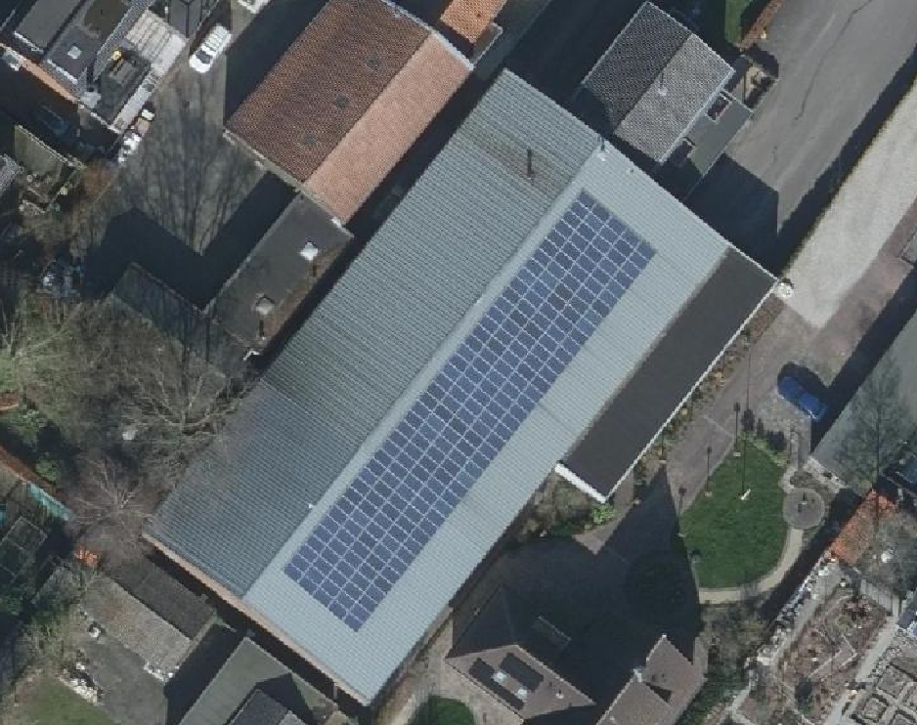 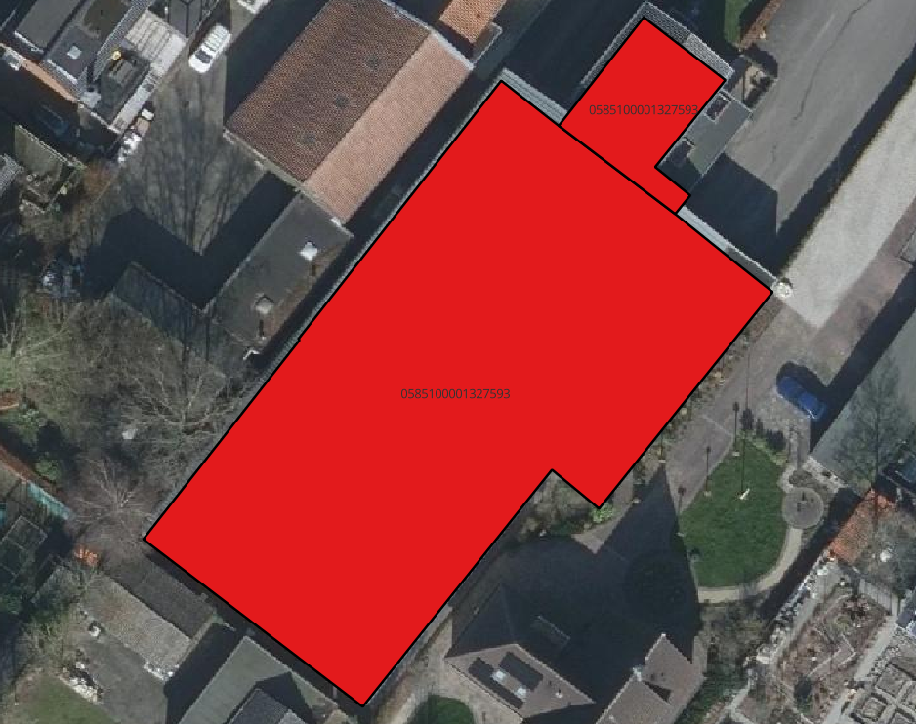

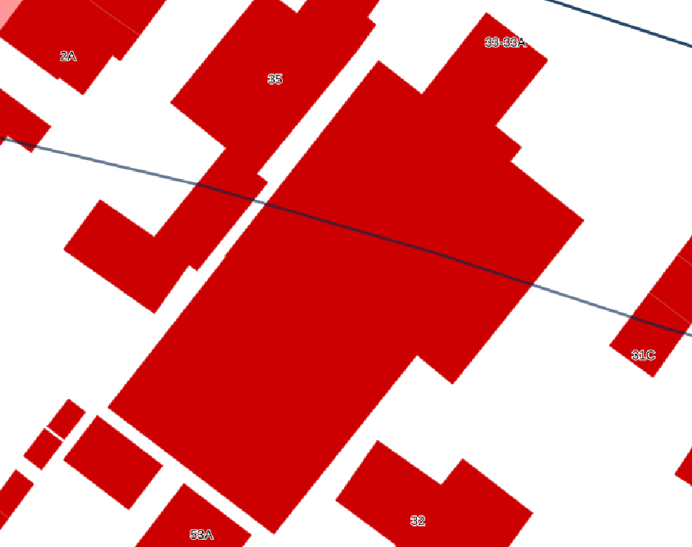 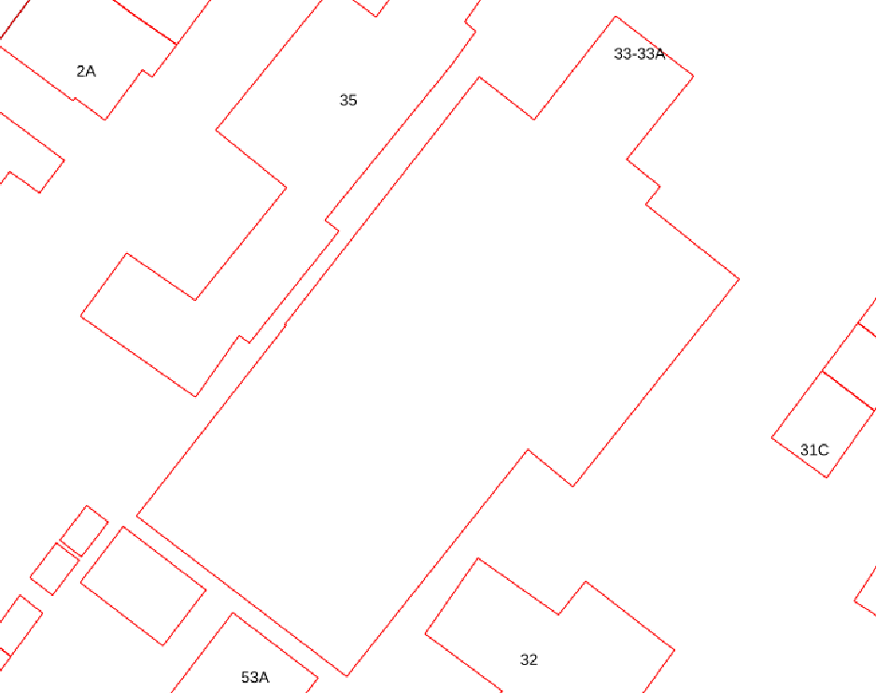

|  |  |  |  |  |
| --- | --- | --- | --- | --- |
| BGT-identificatie | tijdstipregistratie | BAG-identificatie | bronhouder | relatievehoogte |
| G1963.6c40f8703f694c2497bf15cfdee9f487 | 24-11-2022 13:32:54 | 0585100001327593 | G1963 | 0 |
| G0585.8abeacd5439b75760000000a1017e0f0 | 1-8-2022 15:17:15 | 0585100001327593 | G1963 | 0 |

Onjuiste BAG-identificaties en afbakening

**Van der Merckstraat, ’s-Gravendeel**

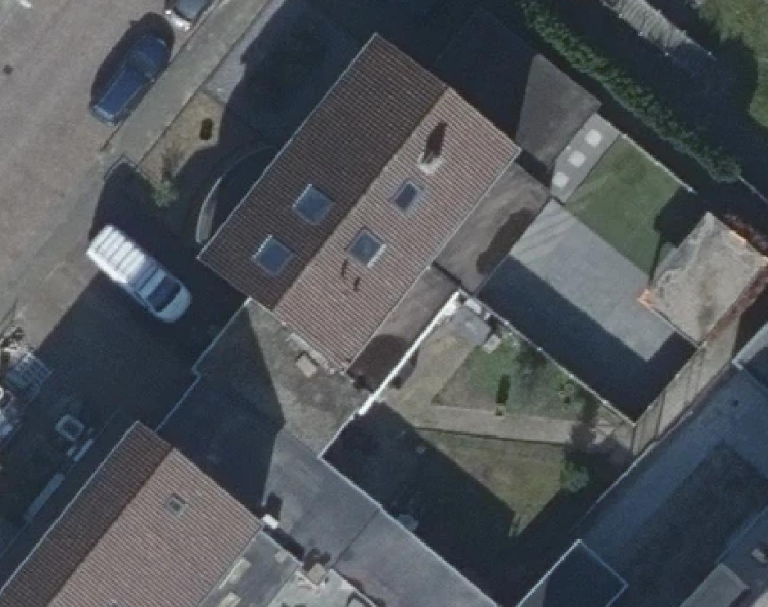

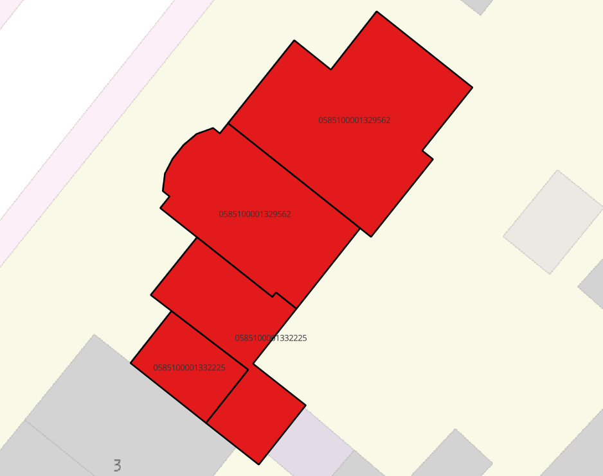 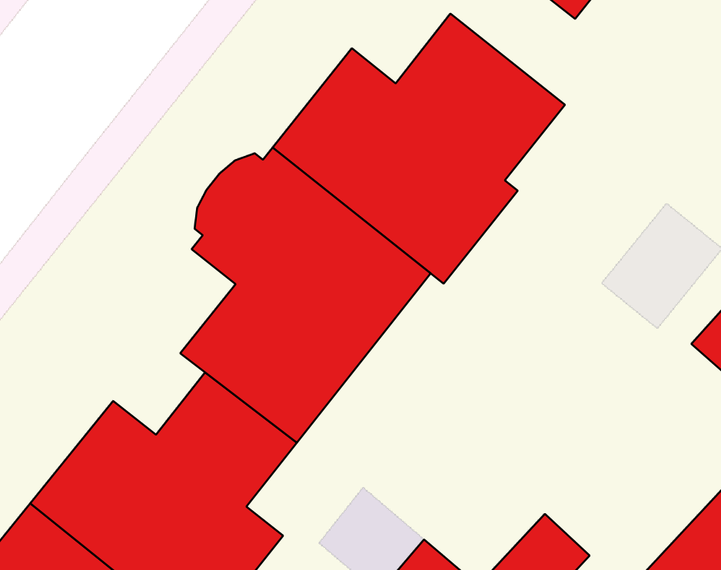

|  |  |  |  |  |
| --- | --- | --- | --- | --- |
| BGT-identificatie | tijdstipregistratie | BAG-identificatie | bronhouder | relatievehoogte |
| G0585.8abeacd5439b75760000000a1319984d | 5-7-2022 14:49:50 | 0585100001329562 | G1963 | 0 |
| **G1963.a7910dfdb00847769c94bf1577df897a** | **24-11-2022 13:32:54** | **0585100001329562(!)** | **G1963** | **0** |
| G1963.093b81dc0a3a4982a42b5ecad7aac28b | 24-11-2022 13:32:54 | 0585100001332225 | G1963 | 0 |
| G0585.8abeacd5439b75760000000a1319927d | 5-7-2022 14:49:50 | 0585100001332225 | G1963 | 0 |